Statement of Environmental Effects

Accompanying a development application for

Tumbarumba Caravan Park Recreation Room

At

Lot 433 DP 755892/Lot 453 DP755892
The Parade, Tumbarumba, NSW, 2653

28/5/2023

DA reference Number: PAN-336397

Contents
- Introduction | Page 3
- Site description and analysis | Page 4
- Details of proposal | Page 7
- Planning considerations | Page 10
- Other considerations | Page 14
- Conclusion | Page 18

- Introduction
This statement of environmental effects has been prepared by Riley Mcmullen to accompany a development application for the Tumbarumba Caravan Park Recreation Room at Lot 433 DP 755892/Lot 453 DP755892 The Parade, Tumbarumba, NSW, 2653. The application is being lodged by Riley Mcmullen pursuant to Clause 4.12 of the Environmental Planning and Assessment Act 1979.

The proposal has been designed to achieve the relevant provisions of the Tumbarumba Local Environmental Plan 2010; the Snowy Valleys Development Control Plan 2019; and Clause 4.15 of the Environmental Planning and Assessment Act 1979 (as amended).

Summary of Proposal
The development proposes the addition of a recreation building to adjoin the existing camp kitchen at the Tumbarumba Caravan Park.

The recreation building will be a 12m x 6m prefabricated modular building which will primarily be used as a TV/lounge room for guests of the caravan park. A new 12m x 3m deck and awning will also be installed out the front of the recreation building and will adjoin the deck off the existing camp kitchen. A smaller 8m x 3m awning will also be installed between the existing camp kitchen and the recreational building. The recreation building will be installed on pier footings with the deck level RL to match the existing deck off the camp kitchen.

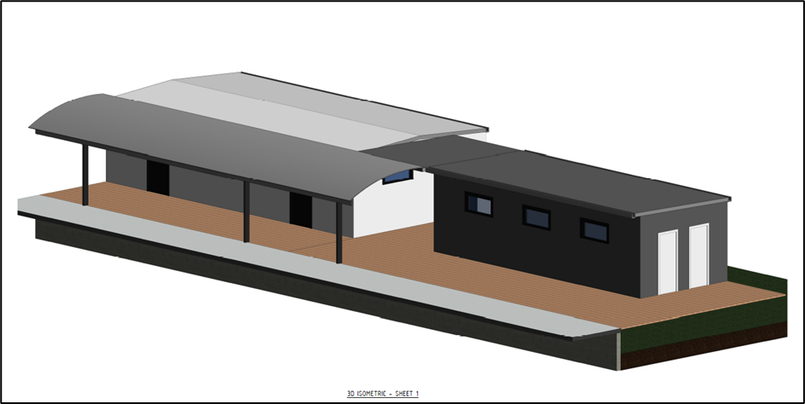
Figure 1 – Isometric view 1 (Existing camp kitchen shown in black)
UGL have committed to the supply and installation of the recreation building with the Snowy Valleys Council/Tumbarumba Caravan Park becoming the asset owner after installation.

- Site description and analysis

  - Location and property description
The Recreation Room will be located at the Tumbarumba Caravan Park adjacent to the existing camp kitchen. The location of the Recreation Room is shown below in red.

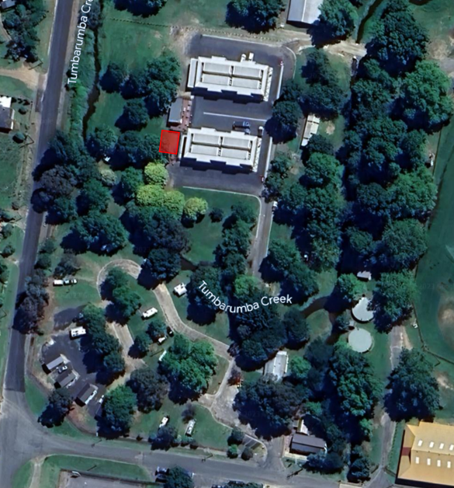
Figure 2 – Site location
  - Site characteristics
The proposed site is flat and sits in the low-lying area adjacent to the Tumbarumba Creek. The area is grassed and there is one (1) tree (exotic species) which will need to be removed. A geotechnical report and flood study of the site were previously completed by ASCT Tumut and WMA Water respectively, both documents are attached to the DA.

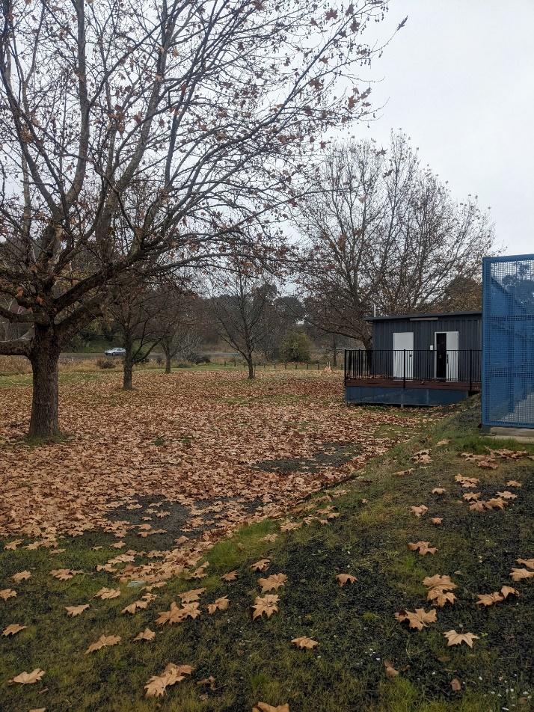
Figure 3 – Site photo 1
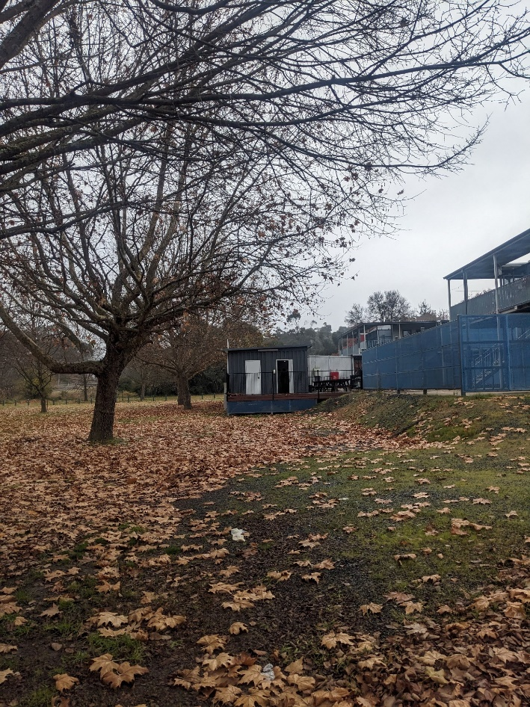
Figure 4 – Site photo 2

  - Surrounding development
The recreation room will be located at the Tumbarumba Caravan Park. Existing buildings at the caravan park include:

- 2 x accommodation blocks
- 4 x cabins
- Camp sites
- 2 x camp kitchens
- 1 x toilet block
- 1 x Caretakers’ residence/office

- Details of proposal

  - Proposed works
The recreation building will be a 12m x 6m prefabricated modular building which will primarily be used as a TV/lounge room for guests of the caravan park. A new 12m x 3m deck and awning will also be installed out the front of the recreation building and will adjoin the existing camp kitchen deck. An 8m x 3m awning will also be installed between the camp kitchen and the recreation room. The building will be attached to a steel frame on pier footings with the deck level RL to match the existing deck off the camp kitchen.

The footings will be constructed by local contractor prior to the arrival of the building. The building will arrive in two 12m x 3m sections. The two sections of the building will be craned into place with the chassis of each sectioned being fastened to the steel frame and the sections bolted together. The steel frame and building will then be lifted on to the footings. The deck and the awning will then be installed. Prior to the installation of the building one tree will need to be removed. The colour scheme of the building can be seen in figure 6, the deck will be brown to match the existing camp kitchen deck.

Please note this is a recreation room used for social purposes and is not a dwelling, it does not have cooking facilities or running water.

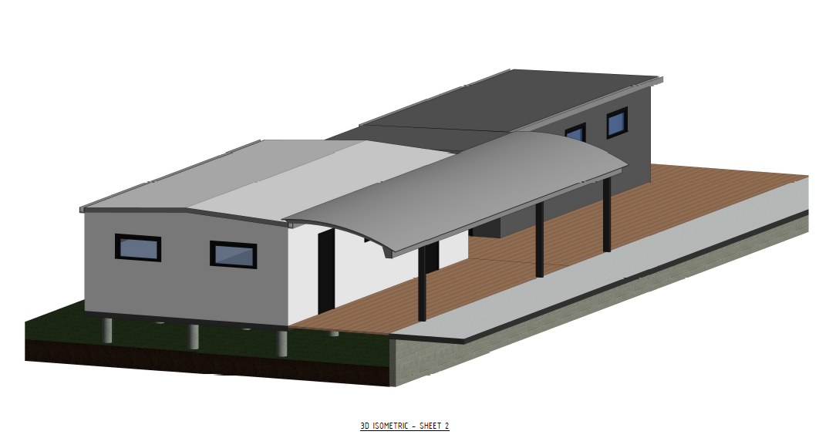
Figure 5 – Isometric view 2 (Existing camp kitchen shown in black)
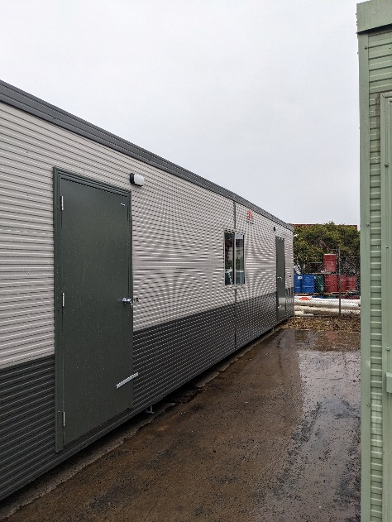
Figure 6 – Prefabricated recreational room
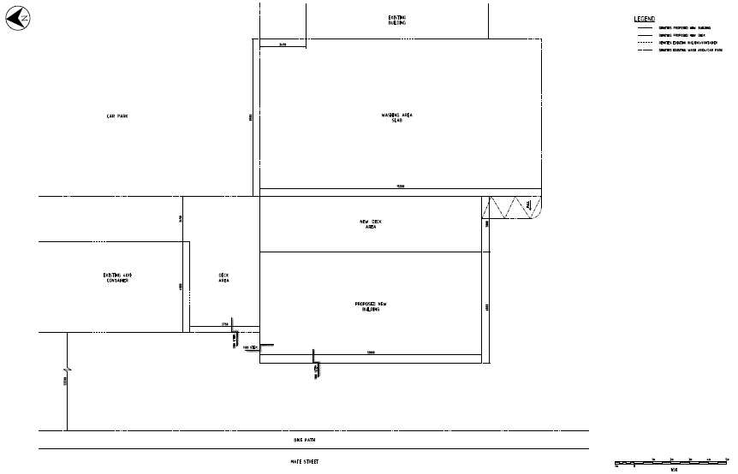
Figure 7 – Site Layout
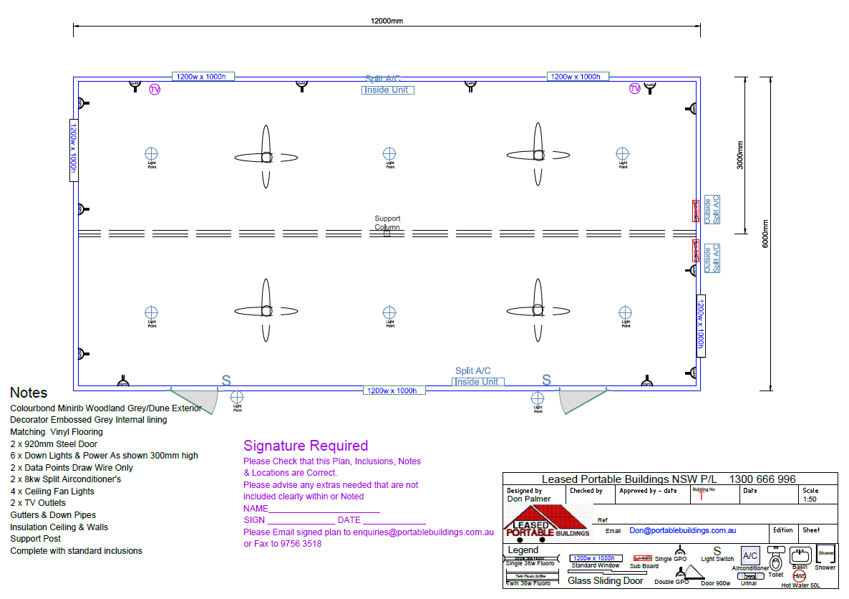
Figure 8 – Floor plan
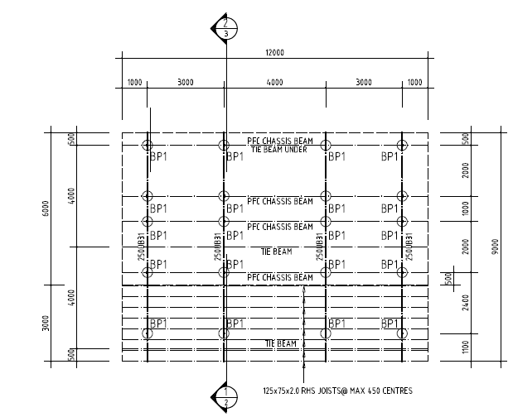
Figure 9 – Steel frame design and pier location

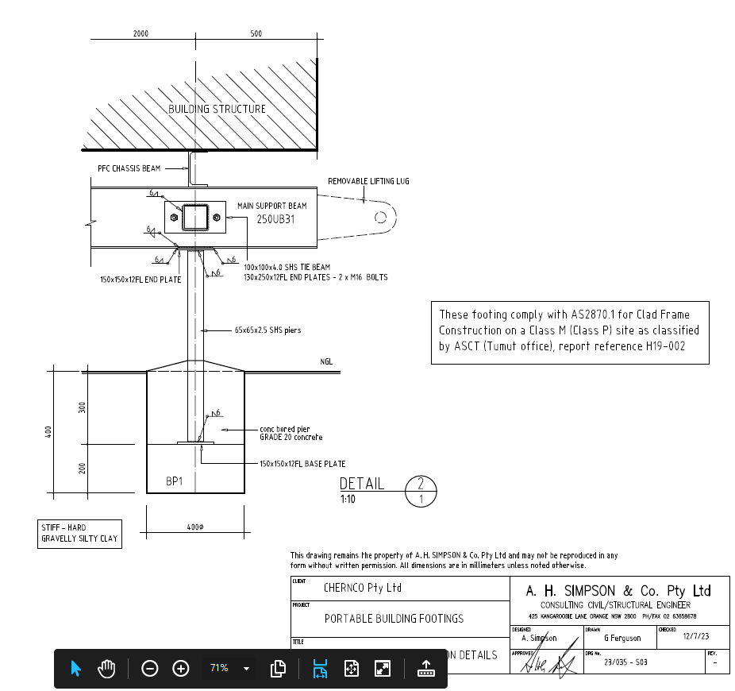
Figure 10 – Footing design
4. Planning Considerations
Pursuant to Clause 4.15 of the Environmental Planning and Assessment Act (1979), the following matters are considered:

4.1 State Environmental Planning Policies
No SEPPs are applicable to this development application.
4.2 Tumbarumba Local Environmental Plan 2010
The applicable LEP clauses are addressed below:

2.1 Land use zones
Comment:
The site is listed as zone RE1 Public Recreation.
Zone RE1 Public Recreation
1 Objectives of zone
• To enable land to be used for public open space or recreation purposes.
• To provide a range of recreation settings and activities and compatible land uses.
• To protect and enhance the natural environment for recreation purposes.
2 Permitted without consent
Nil
3 Permitted with consent
Advertising structures; Air transport facilities; Airstrips; Aquaculture; Boat launching ramps; Boat sheds; Camping grounds; Car parks; Caravan parks; Community facilities; Emergency services facilities; Entertainment facilities; Environmental facilities; Environmental protection works; Food and drink premises; Helipads; Information and education facilities; Jetties; Kiosks; Marinas; Markets; Mooring pens; Recreation areas; Recreation facilities (indoor); Recreation facilities (major); Recreation facilities (outdoor); Research stations; Roads; Sewerage systems; Water supply systems
4 Prohibited
Any development not specified in item 2 or 3
Comment:
The proposed development is consistent with the objectives of the zone.
5.10 Heritage Conservation
Comment:
The site is not in a heritage conservation zone.
5.21 Flood planning
(1) The objectives of this clause are as follows—
(a) to minimise the flood risk to life and property associated with the use of land,
(b) to allow development on land that is compatible with the flood function and behaviour on the land, taking into account projected changes as a result of climate change,
(c) to avoid adverse or cumulative impacts on flood behaviour and the environment,
(d) to enable the safe occupation and efficient evacuation of people in the event of a flood.
(2) Development consent must not be granted to development on land the consent authority considers to be within the flood planning area unless the consent authority is satisfied the development—
(a) is compatible with the flood function and behaviour on the land, and
(b) will not adversely affect flood behaviour in a way that results in detrimental increases in the potential flood affectation of other development or properties, and
(c) will not adversely affect the safe occupation and efficient evacuation of people or exceed the capacity of existing evacuation routes for the surrounding area in the event of a flood, and
(d) incorporates appropriate measures to manage risk to life in the event of a flood, and
(e) will not adversely affect the environment or cause avoidable erosion, siltation, destruction of riparian vegetation or a reduction in the stability of river banks or watercourses.
(3) In deciding whether to grant development consent on land to which this clause applies, the consent authority must consider the following matters—
(a) the impact of the development on projected changes to flood behaviour as a result of climate change,
(b) the intended design and scale of buildings resulting from the development,
(c) whether the development incorporates measures to minimise the risk to life and ensure the safe evacuation of people in the event of a flood,
(d) the potential to modify, relocate or remove buildings resulting from development if the surrounding area is impacted by flooding or coastal erosion.
(4) A word or expression used in this clause has the same meaning as it has in the Considering Flooding in Land Use Planning Guideline unless it is otherwise defined in this clause.
(5) In this clause—
Considering Flooding in Land Use Planning Guideline means the Considering Flooding in Land Use Planning Guideline published on the Department’s website on 14 July 2021.
flood planning area has the same meaning as it has in the Floodplain Development Manual.
Floodplain Development Manual means the Floodplain Development Manual(ISBN 0 7347 5476 0) published by the NSW Government in April 2005.

Comment:
The site is in a recognised flood zone. The deck level of the proposed Recreation Room will match the level of the existing camp kitchen deck. A survey of the site completed by Rivland Surveyors identified the existing camp kitchen deck had an AHD of 632.74m. This is above the flood level requirements specified in the flood study completed out by WMA water in 2016. The flood study is attached to the DA and is available for the certifier to review.
The Recreation Room will be situated on 20 pier foundations as shown in Figure 9 and Figure 10 on Page 9. As the floor and deck level is raised above the flood level AHD in the event of a flood, water will be able to flow under the building, as such the impact of the building on floodplain storage and behaviour is negligible.
6.2 Biodiversity
Comment:
The site is not in a biodiversity zone.
6.3 Land
(1) The objective of this clause is to maintain soil resources and the diversity and stability of landscapes, including—
(a) protecting land with steep slopes and shallow soils, and
(b) protecting land subject to soil salinity, and
(c) protecting land with high erosion potential soils, and
(d) protecting land susceptible to other forms of land degradation, and
(e) protecting landforms.
(2) This clause applies to all the land to which this Plan applies.
(3) Before determining a development application for land to which this clause applies, the consent authority must consider any adverse impact from the proposed development in relation to—
(a) the geotechnical stability of the site, and
(b) the probability of increased erosion or other land degradation processes.
(4) Development consent must not be granted to development on land to which this clause applies unless the consent authority is satisfied that—
(a) the development is designed, sited and will be managed to avoid any adverse environmental impact, or
(b) if that impact cannot be avoided—the development is designed, sited and will be managed to minimise that impact, or
(c) if that impact cannot be minimised—the development will be managed to mitigate that impact.

Comment:
The development requires the installation of pier footings to support the recreation building. The foundations will be designed based on Geotechnical Report H19-002 by ASCT.
4.3 Snowy Valleys Development Control Plan 2019
The applicable LEP clauses are addressed below:

Clause | Heading | Comment
3.2.1 | Vehicle Access Standards | Complies. No changes to existing development.
3.2.2 | Bushfire | Complies.  The land is mapped as bushfire prone. The location is practical for access and allows a fire truck to then manoeuvre around either side of the development, through the landscape, to access all sides of the Asset Protection Zone. There is water mains access onsite including access to fire hoses. There is no change to the current fire risk of buildings on-site.
3.2.3 | Car Parking | Complies. No change to existing development.
3.2.3.2 | Car Parking Layout | Complies. No change to existing development.
3.2.3.3 | Car Parking for Changes of Use in Existing Commercial Buildings | Not applicable.
3.2.4 | Construction Over Council Land and Services | Complies.  The building will be constructed on Council land and once construction is complete it will become an asset of the Snowy Valleys Council/Tumbarumba Caravan Park.  During construction appropriate measures will be taken to ensure the safety of caravan park guests and workers.  No council easements or services will be impacted by the project.
3.2.5 | Contaminated Land | Not applicable.
3.2.6 | Cut and Fill | Not applicable.
3.2.7 | Demolition | Not applicable.
3.2.8 | Development Near Electrical Easements | Not applicable.
3.2.9 | Erosion and Sediment Control | Complies.  Sediment fence will be installed downslope of site if deemed necessary. The surrounding groundcover will be revegetated at the completion of the works if required.
3.2.10 | Flooding | Complies.  The deck level of the proposed Recreation Room will match the level of the existing camp kitchen deck. A survey of the site completed by Rivland Surveyors showed the existing camp kitchen deck had an AHD of 632.74m. This is above the flood level requirements specified in the flood study completed out by WMA water in 2016. The flood study is attached to the DA and available for the certifier to read.  The Recreation Room will be situated on 20 pier foundations as shown in Figure 9 and Figure 10 on Page 9. As the floor and deck level is raised above the flood level AHD in the event of a flood, water will be able to flow under the building, as such the impact of the building on floodplain storage and behaviour is negligible.
3.2.11 | Heritage | Complies.  Development does not occur within a heritage conservation area.
3.2.12 | Landscaping | Complies.  One (1) tree (exotic species) to be removed near the Southwest corner of the recreation building prior to construction.
3.2.13 | On-site Wastewater Management | Not applicable.  The building will not produce wastewater.
3.2.14.1 | Sewage | Not applicable.  The building will not produce sewage.
3.2.14.2 | Water Supply | Not applicable.  The building will not be connected to mains water or rainwater.
3.2.14.3 | Electricity | Complies.  The development will be connected to mains electricity.
3.2.14.4 | Telecommunications | Not applicable.
3.2.15 | Retaining Walls | Not applicable.
3.2.16 | Safer by Design | Not applicable.
3.2.17 | Stormwater/roof Water Management | Complies.  Stormwater, roof water and rainwater overflow will be directed to existing outlet on-site.

5. Other Considerations
5.1 Visual Impacts
The proposed Recreation Room will have minimal visual impacts due to the small project footprint and aesthetic similarity to existing buildings in the vicinity.

5.2 Open Space
One (1) tree (exotic species) to be removed near the Southwest corner of the recreation building prior to construction.
Tree to be removed.
Figure 11 – Tree removal

5.3 Overshadowing and Privacy
The building is one-storey and will match the height of the existing camp kitchen. Therefore, there will be no overshadowing or privacy implications.

5.4 Noise
The development will not impact on noise in the area.

5.5 Erosion Control Measures
Minimal earthworks are required as part of the project. Sediment fence will be installed downslope of site if deemed necessary during the works. The surrounding groundcover will be revegetated at the completion of the works if required.

5.6 Economic and Social Impacts
The development is predicted to increase wellbeing among the caravan park occupants as it will provide a safe space to socialise. The recreation room will also add to the existing facilities of the caravan park could result in increased visitors and returning guests to the park adding to increased revenue.

5.7 Environmental Benefits
There are no foreseen environmental benefits.

5.8 Disabled Access as per AS1428.1 2021
Please see attached document named Rec Room AS1428 Compliance.

5.9 Security, Site Facilities and Safety
There is no proposed security or safety issues.

5.10 Waste Management
The building will not generate any sewage or wastewater. General waste will be negligible and will therefore not impact on the current levels of waste being produced at the site.

5.11 Building Code of Australia
All works to comply with relevant Australian Standards. Please see development application attachments for details.

5.12 Traffic
The development will have no impact on current traffic levels.

5.13 Stormwater/flooding
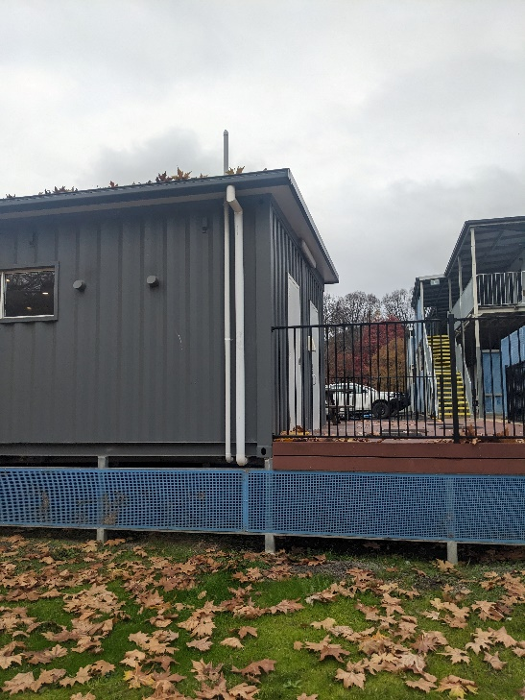
The catchment area of the roof is (12m x 6m) = 72m² and it proposed to direct the stormwater into the existing drainage system off the camp kitchen.
Figure 12 – Stormwater connection point at camp kitchen

The deck level of the proposed Recreation Room will match the level of the existing camp kitchen deck. A survey of the site completed by Rivland Surveyors showed the existing camp kitchen deck had an AHD of 632.74m. This is above the flood level requirements specified in the flood study completed out by WMA water in 2016. The flood study is attached to the DA and available for the certifier to read.

The Recreation Room will be situated on 20 pier foundations as shown in Figure 9 and Figure 10 on Page 9. As the floor and deck level is raised above the flood level AHD in the event of a flood, water will be able to flow under the building, as such the impact of the building on floodplain storage and behaviour is negligible.

5.14 BASIX
In reference to NCC 2022 Volume 1, Part A6 Building Classification; The proposed development is classified as a class 9b Assembly building used for social purposes. A BASIX assessment is not required for a building of this class.
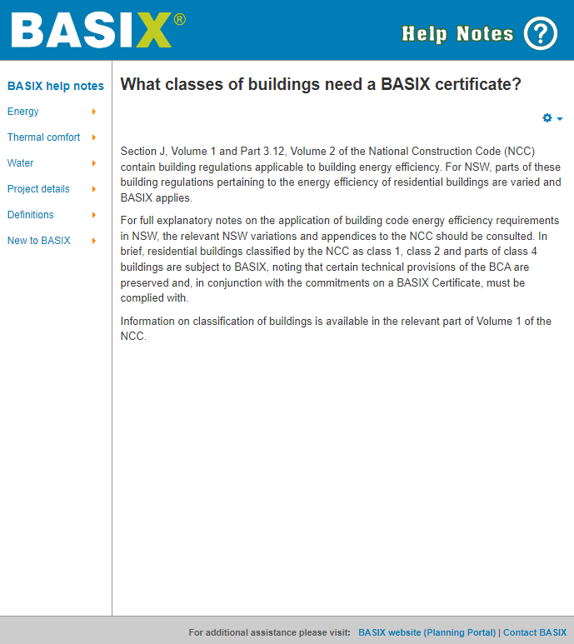
Figure 14 – BASIX requirements

6.0 Conclusion
This report includes an analysis of the project context, details of the proposed development and consideration of applicable statutory requirements. Based upon the investigations of the proposal it can be concluded that:
- The quality and amenity of neighbouring residents will not be impacted as a result of the development proceeding;
- There will be negligible effects on traffic;
- Utilities required for the proposal (Electricity only) are already available on site;
- The proposed recreation building and associated footings have been designed and will be constructed to the applicable Australian building codes and standards;
- The recreation building will become an asset of the Snowy Valleys Council/Tumbarumba Caravan Park upon the completion of construction;
- The proposal is generally consistent with the objectives and provisions of Councils relevant planning documents;

Accordingly, UGL request that the Development Application be approved subject to appropriate standard conditions.

